“Empowering Every Child in Learning Life Skills”

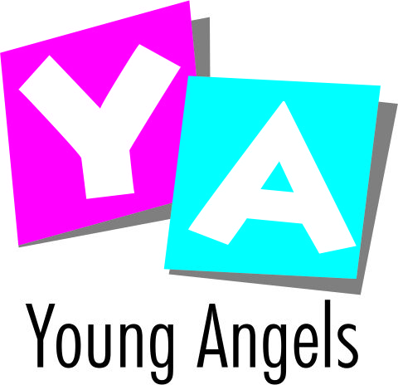

Dear Parent,

“Learning How to Learn is Life's Most Important Skill" — Tony Buzan

Reading and writing instill life-long learning skillsin your child, and build a foundation for achieving academic success.In an endeavor to help children become super readers, Young Angels, in association with The Champs International ,Faridabad, is presenting monthly ELS magazines as“a special way to improve the life skills of your children”.

These magazines have been carefully designed and developed after in-depth research under the expert guidance and supervision of experienced faculties from the field of education. Their content has been prepared in accordance with the guidelines laid down by CBSE and other educational boards.This assessment kit will be available for academic session April, 2017 to March, 2018 (12 Months Content) along with 10 Activity Books for classes Nursery to IInd. It will cater to the domains listed under the category of Co-Scholastic areas.

This kit is aimed at making education an enjoyable process for both the learner as well as the educator. The teachers will guide and help you with its subscription. We request you to allow your child to enroll in this program.

Looking forward to your whole-hearted support.

